**DATA SCIENCE CAPSTONE**

**By Susan Nelson**

**BUSINESS PROBLEM**

The objective of this analysis is to provide hotels, and possibly other organizations including local lifestyle magazines or newspapers in the city of Toronto with a listing of the top restaurants in specific areas with breakdowns by type, so they can provide this data to their guests. Additionally, this data can be offered on their website to attract customers. We can charge a subscription fee to provide this data on a quarterly basis in order to include the newer establishments and the latest trends. In order to provide a list relevant to their market, we will cluster Toronto based on Postal Codes, then based on the groupings, we will identify the top venues within the clusters.

**DATA**

In order to support this analysis, we require geographical data for Toronto including neighborhoods, post codes, boroughs and corresponding latitudes and longitudes. This data will be used to define geographical clusters. Additionally, we can tap into data from Four Square to analyze the top eateries and other venues that correspond to these clusters.

Wikipedia, generally speaking, is a great source for a wide variety of information and data. We can leverage Wikipedia to capture a listing of Toronto’s boroughs, post codes and neighborhoods. This will serve as the foundation for the geographical clusters. The following URL provides us with a listing of post codes, boroughs and neighborhoods in Toronto: <https://en.wikipedia.org/wiki/List_of_postal_codes_of_Canada:_M>

According to Wikipedia, this list includes postal codes that begin with ‘M’ which indicates that these post codes are within the city of Toronto.

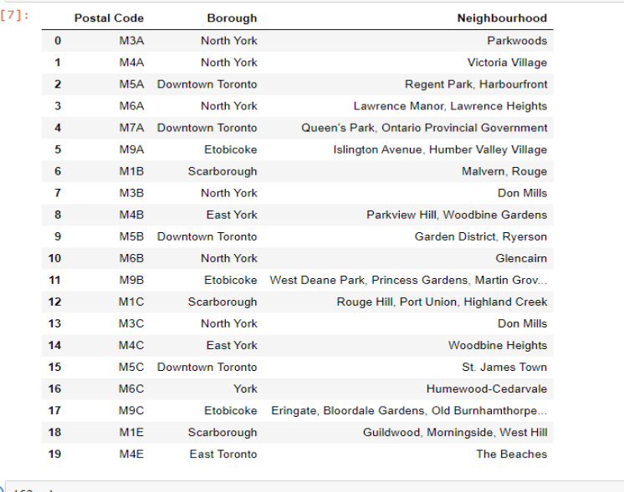

Next, we need to extend the data set with latitude and latitudes per Post Code. The following URL provides this mapping in order to attach the original data set with the corresponding latitude and longitudes: <https://cocl.us/Geospatial_data>.

In order for this data to be useful, we need to do a small amount of data cleansing. First, we must exclude any boroughs with a value of ‘Not Assigned’. Second, we need to collapse the rows resulting from multiple neighborhoods per post code and borough by creating a comma delineated list of neighborhoods aggregated by post code and borough. This step is necessary as we will capture latitude and longitudes per post code, not neighborhood. See the sample data below.

The last data source is four square which provides us with list of venues within Toronto along with the corresponding venue category/type, post code, and latitude and longitude among other characteristics. Foursquare is a location technology platform that offers an API where we can extract location-venue data, with only a few constraints for the “community” (free) version. We can use an API to extract current venue data for Toronto. We can associate the venues with the clusters we create and provide summaries regarding the most visited venues by type of venue.

We create an API to harvest this data and merge it with the Post Code/Neighborhood data set. We use a function that structures the data and also defines the latitude and longitude per neighborhood to which the venue belongs, in addition to the latitude and longitude that corresponds to the venue itself.

**METHODOLOGY**

In order to make the dataset more useful and relevant to an audience based out of a specific area of Toronto, we create clusters based on the latitude and longitudes per a given neighborhood. We use K Means clustering to create 6 distinct clusters within Toronto which groups neighborhoods that are in relatively closer proximity to the others. K Means Clustering is an unsupervised machine learning method.

Once clusters are defined per post code and borough, we simply merge this dataset with the list of venues in order to define the cluster per venue. This gives us a complete data set with 6 cluster that include all relevant Postal Codes, Boroughs, Neighborhoods, venues, and venue categories within Toronto.

**RESULTS**

The following results shows Toronto with all relevant Boroughs plotted on the map (left) and then the same Boroughs color coded by cluster (right).

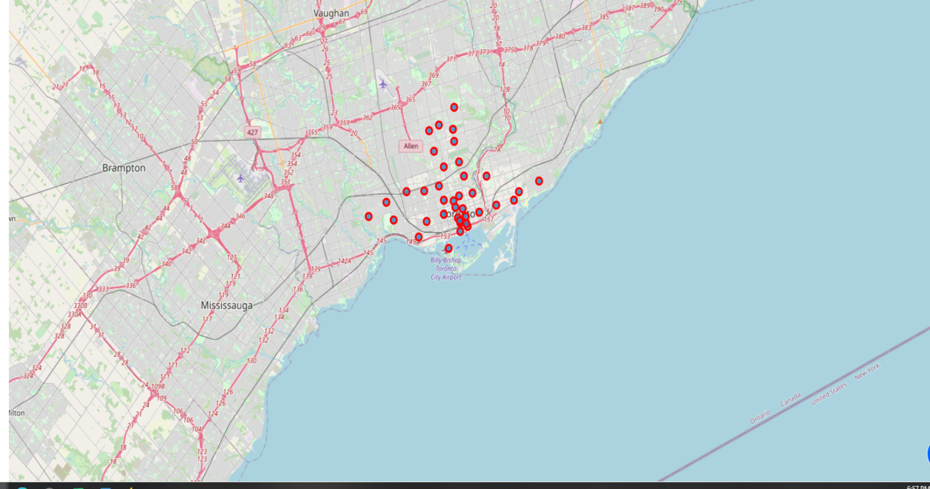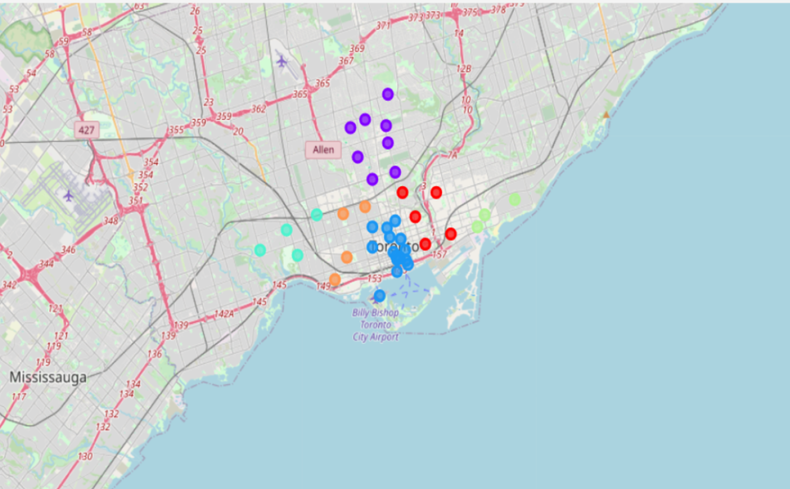

The following table summarized the clusters and which Postal Codes, Borough and Neighborhood to which belong.

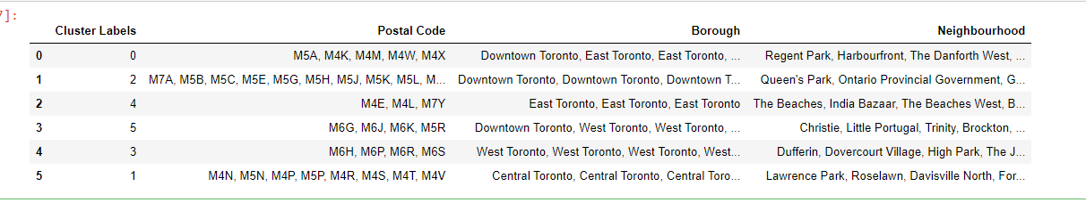

The following is the final data set that would be provided to interested parties for venues in close proximity to their establishment with the corresponding venue category. They can choose to buy corresponding data for one or many clusters.

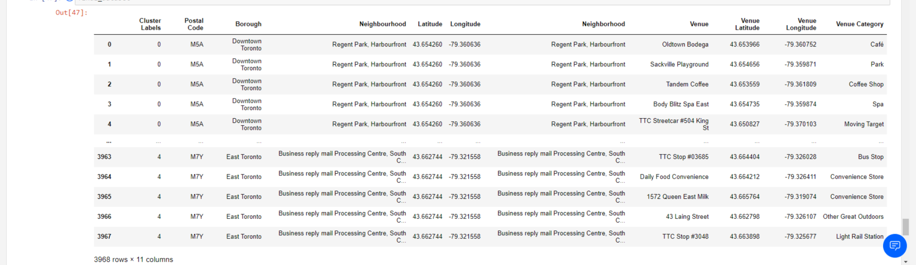

In total there are 3,969 venues that correspond to our Toronto Clusters.

A map such as the following could be provided along with the data set. Alternatively, the color coding could be based on venue type. 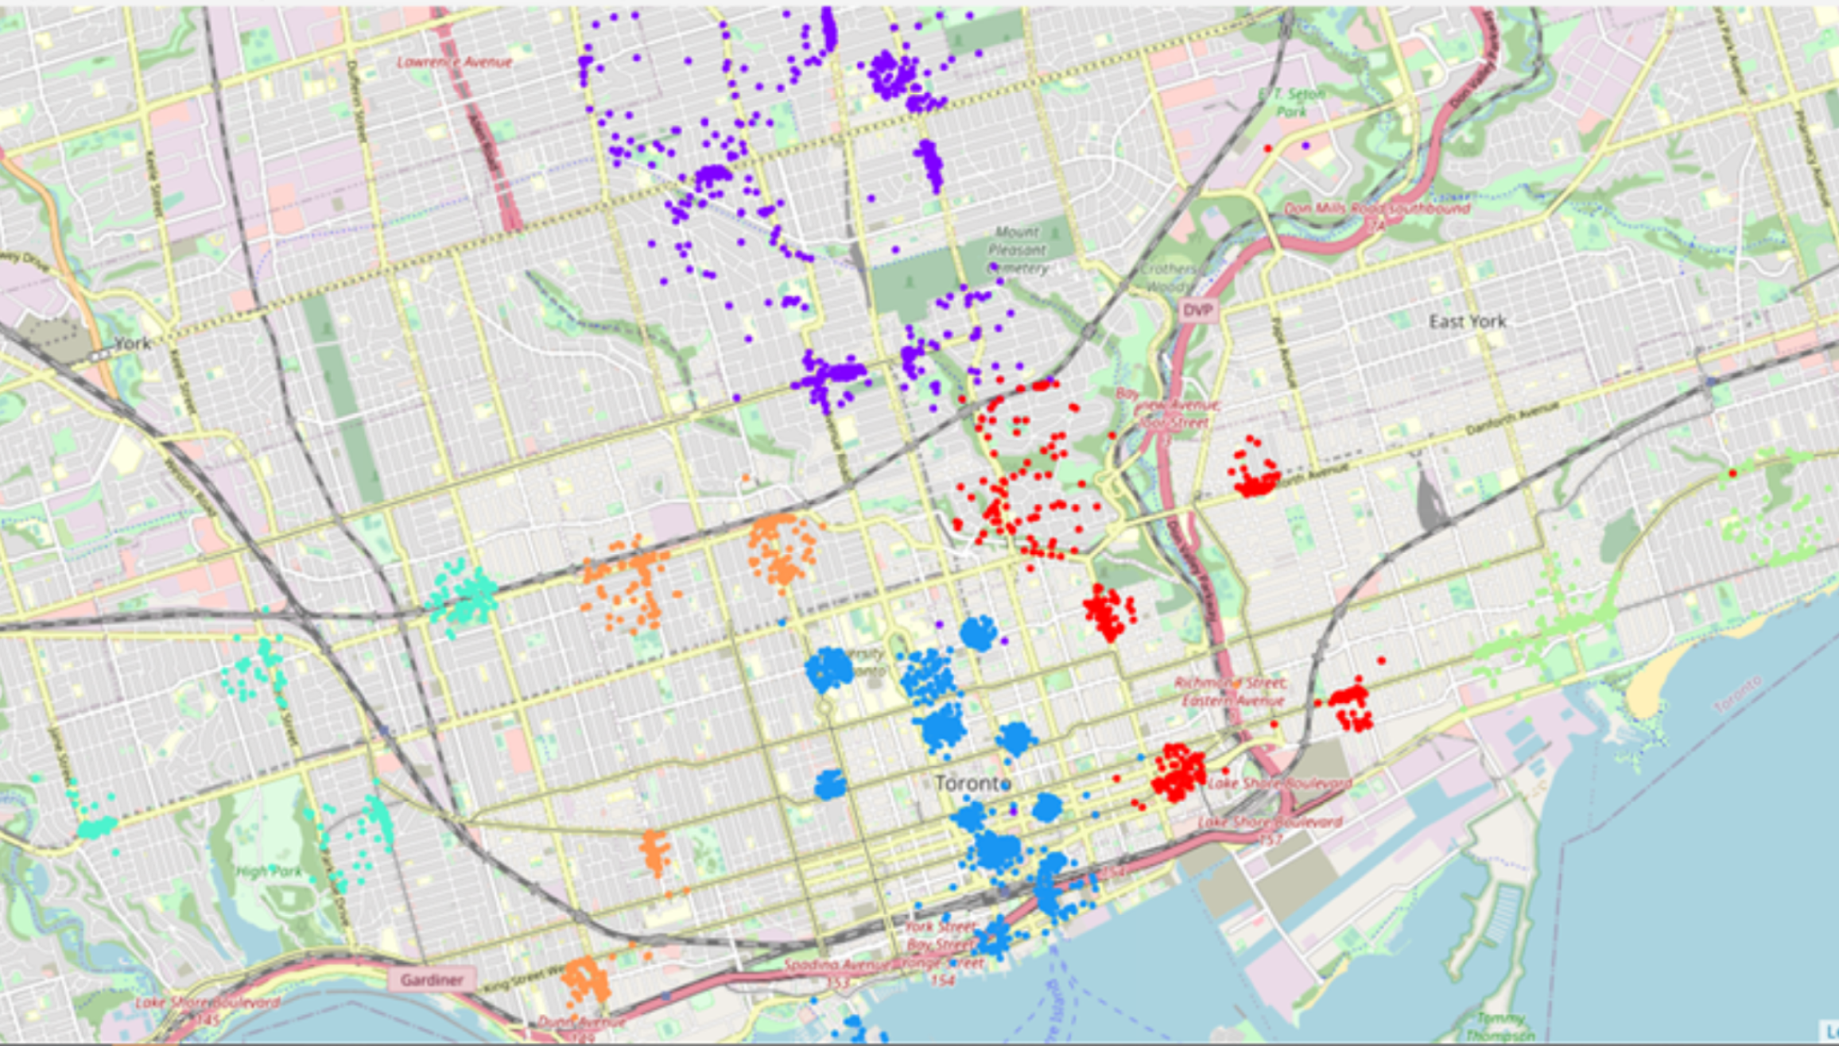

The following table shows the total number of venues within each cluster:

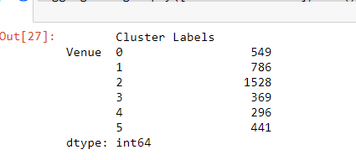

**RECOMMENDATION**

As stated previously, we can offer this dataset as a subscription service to clients so they can get the most current listing of venues.

To make this data more insightful, we could harvest the rating data and sort based on the highest ratings. Additionally, we could create a venue recommendation engine based on the user information a hotel guest provides to suggest places they may be interested in visiting on their stay.

The number of clusters change be easily changed depending on the requirements of the customer.

All of this data could be packaged together in the form of an app and be provided as a plug-in as extension to the hotel’s or other businesses website for a user to search and map out.

**CONCLUSION**

In summary, we were able to gather and merge data from a variety of free sources, apply a simple clustering model to enrich that data and packaged it in a way to make it commercially viable. While many tools and apps have existed for many years exist that allow users to find venues in close proximity to a given location, there is still untapped territory in terms of enhancing and enriching these tools by adding new features and applying data science techniques to improve the user experience and for businesses to entice consumers and offer value added services through geographic analytics.